**Model Development Phase Template**

|  |  |
| --- | --- |
| Date | 24 June 2025 |
| Team ID | xxxxxx |
| Project Title | Credit Card Approval Prediction |
| Maximum Marks | 4 Marks |

**Initial Model Training Code, Model Validation and Evaluation Report**

The initial model training code is showcased through a screenshot. The model validation and evaluation report includes classification reports, accuracy, and confusion matrices for multiple models, presented through respective screenshots.

**Initial Model Training Code:**

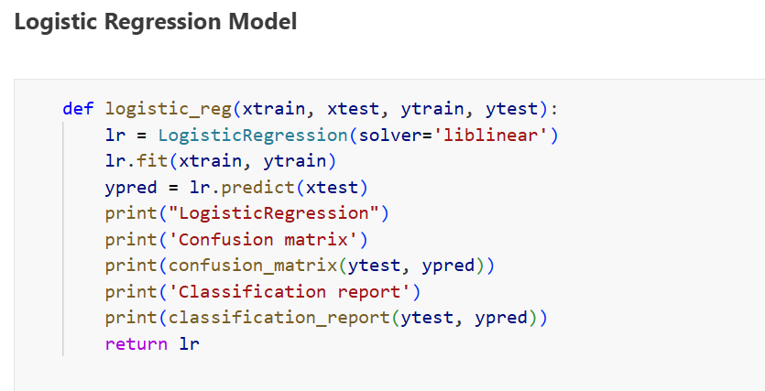

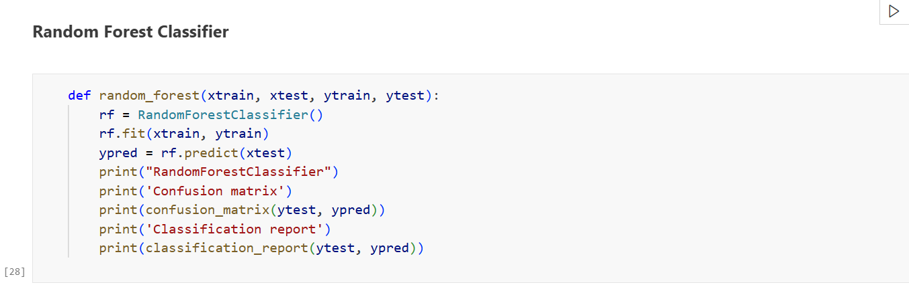

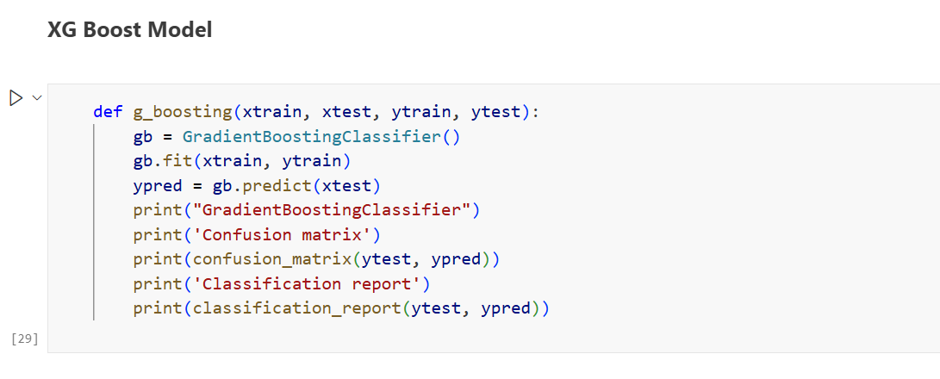

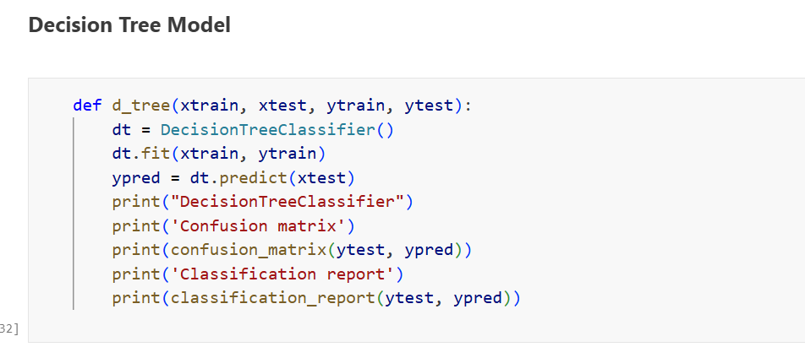

**Model Validation and Evaluation Report:**

|  |  |  |  |
| --- | --- | --- | --- |
| **Model** | **Classification Report** | **Accuracy** | **Confusion Matrix** |
| Logistic Regression |  | 99% |  |
| Random Forest Classifier |  | 99% |  |
| Gradient Boosting Classifier |  | 100% |  |
| Decision Tree Classifier |  | 100% |  |